CHARUSAT UNIVERSITY :
Website Wireframe Document Submitted By: Name : Parthrajsinh H. Gohil :
Enrollment No. : 25DIT019 :
Department : Information Technology Subject : Web Development.

1.INDEX.HTML:
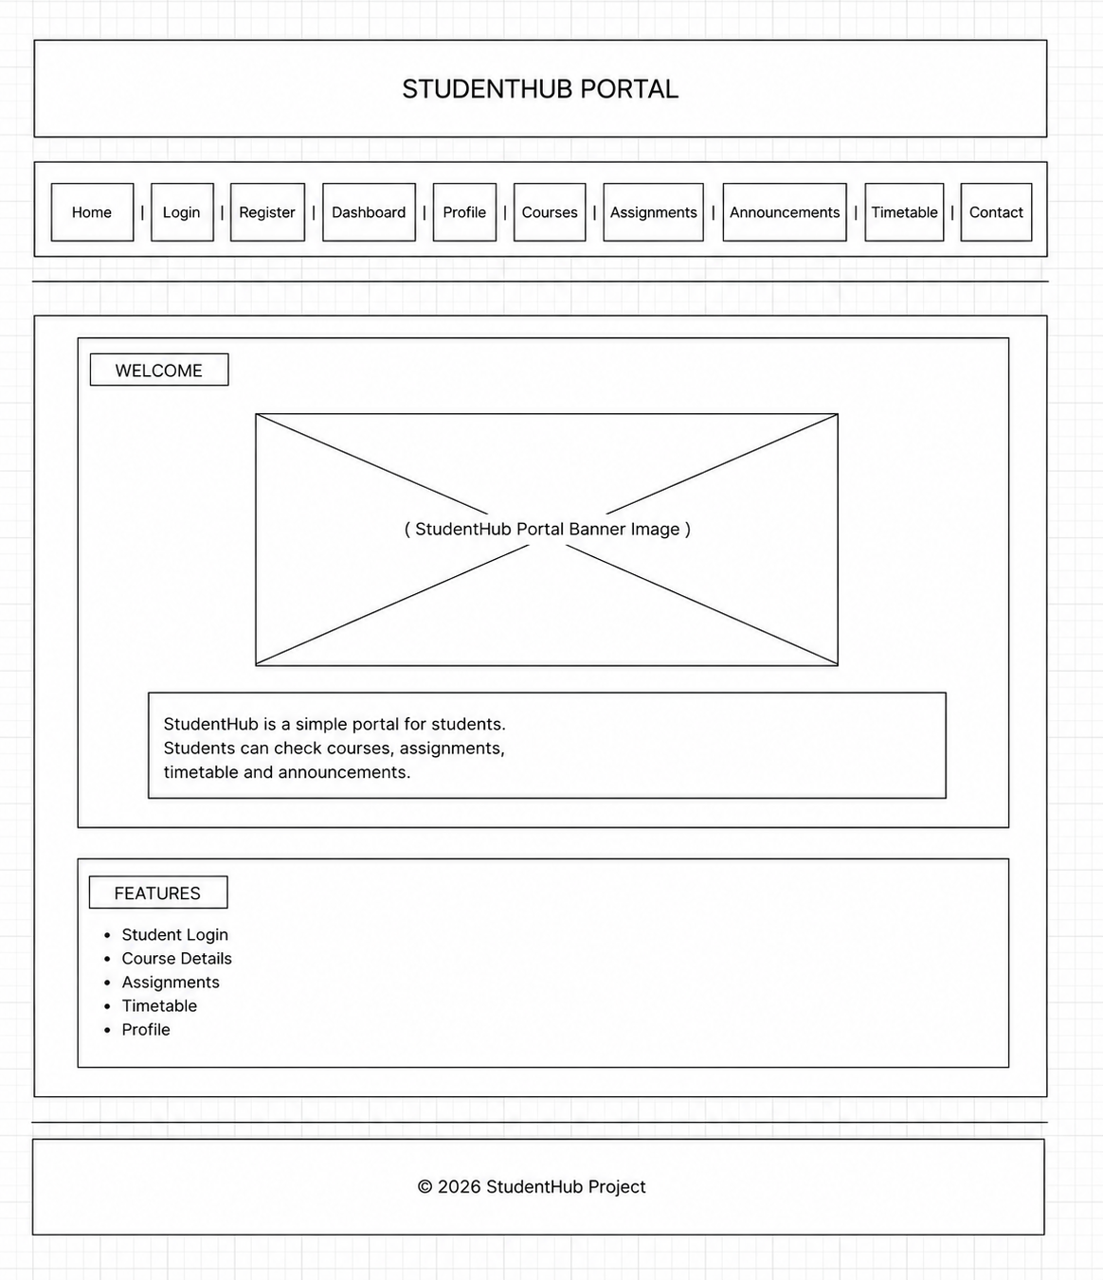

2.Login.html:
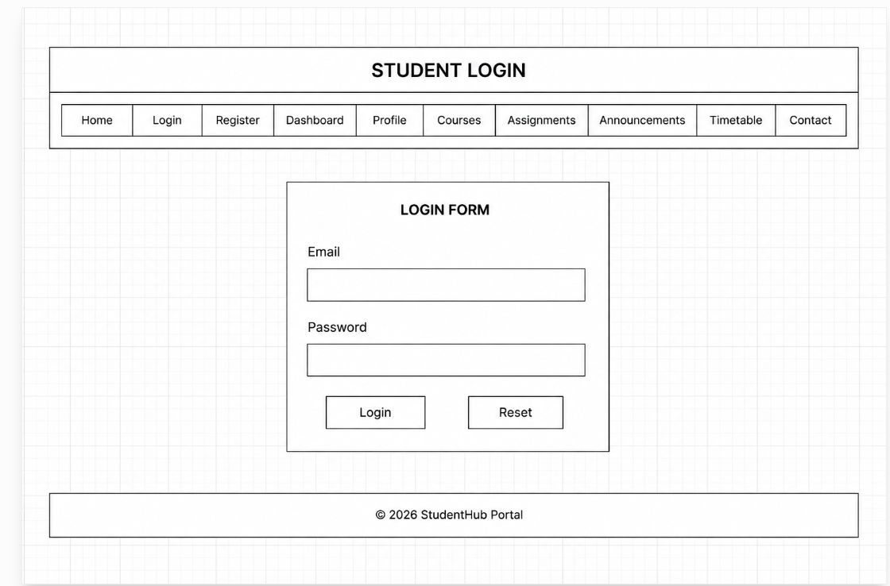

3.Register.html
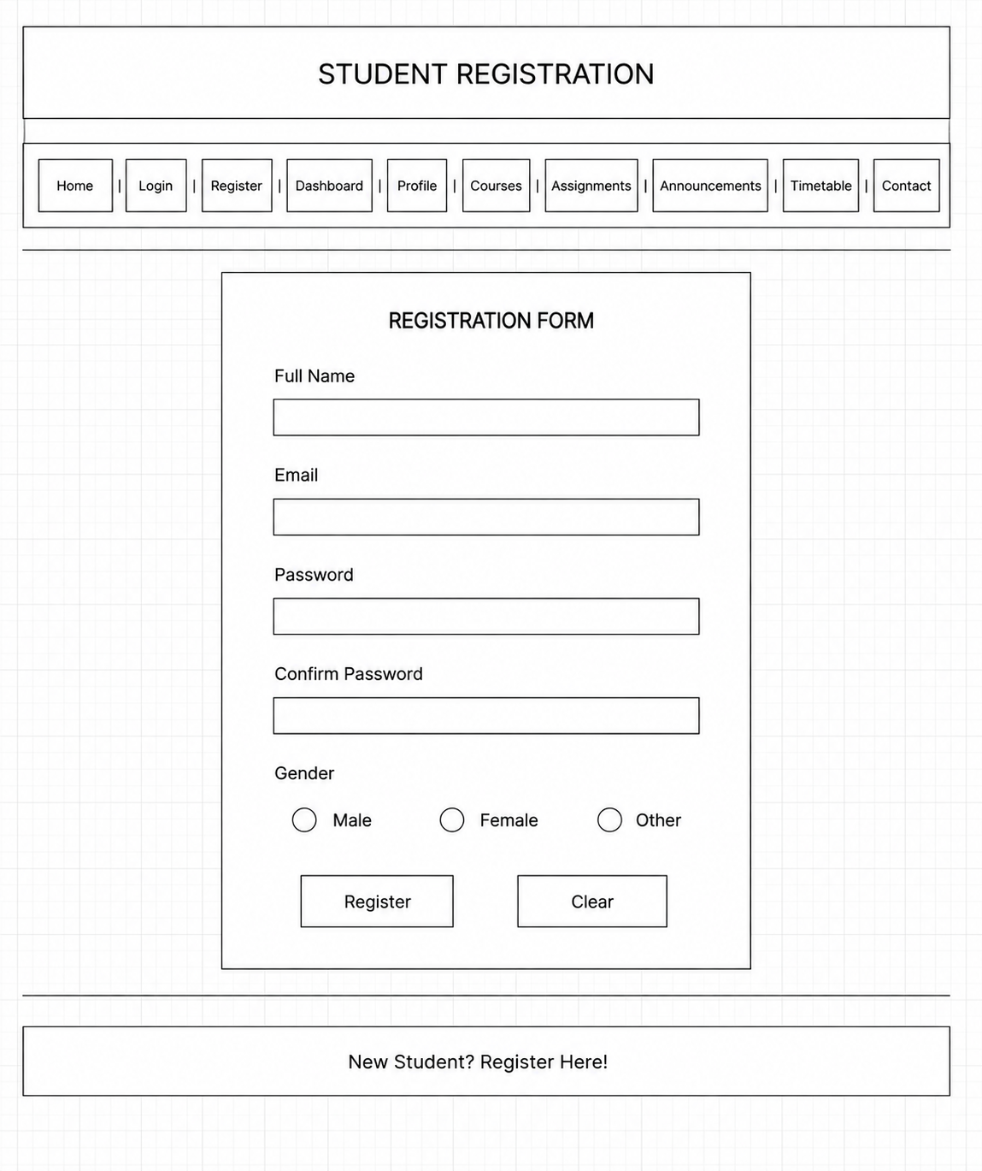
4.dashbord.html
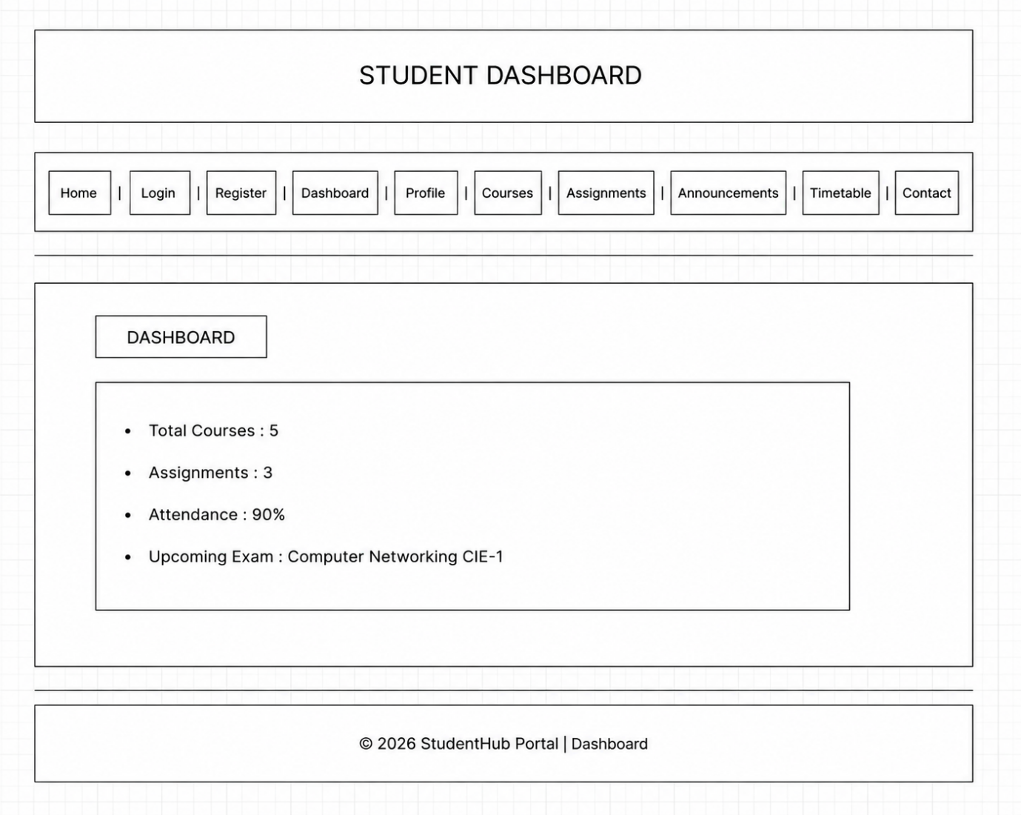
5.profile,html
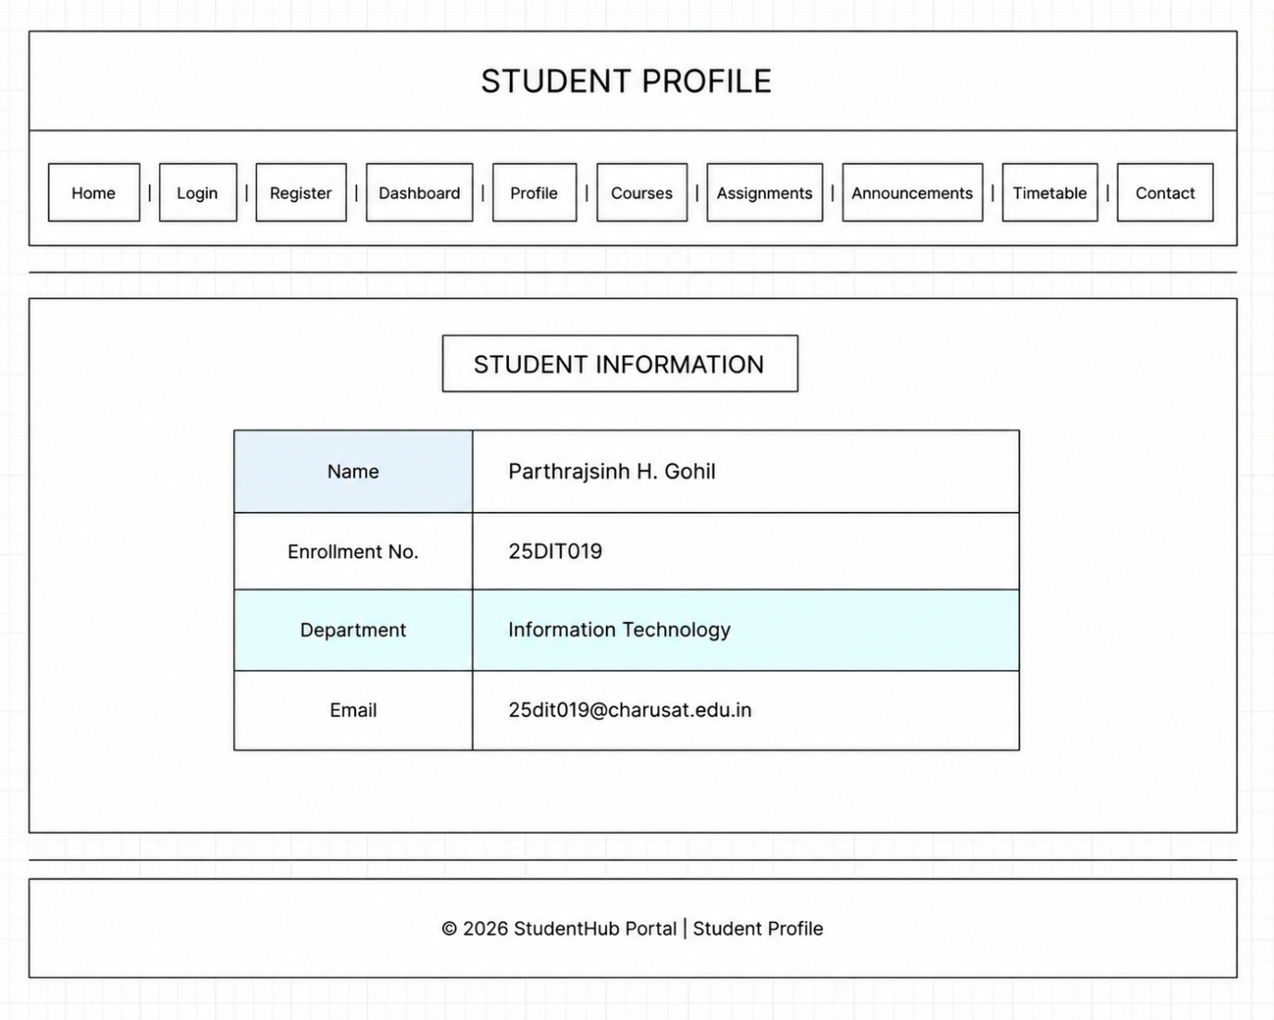

6.course.html
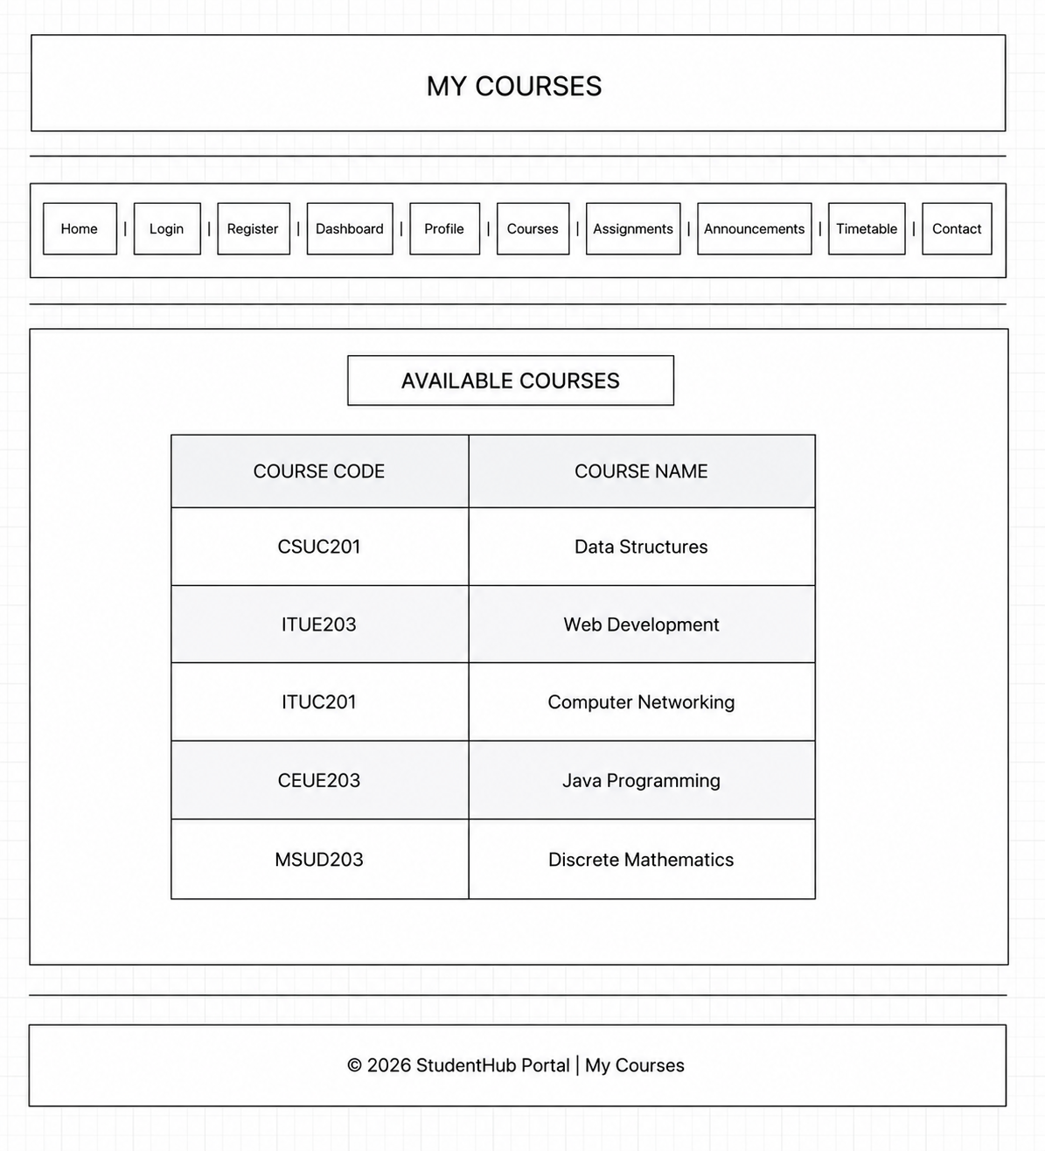

7.assingment.html
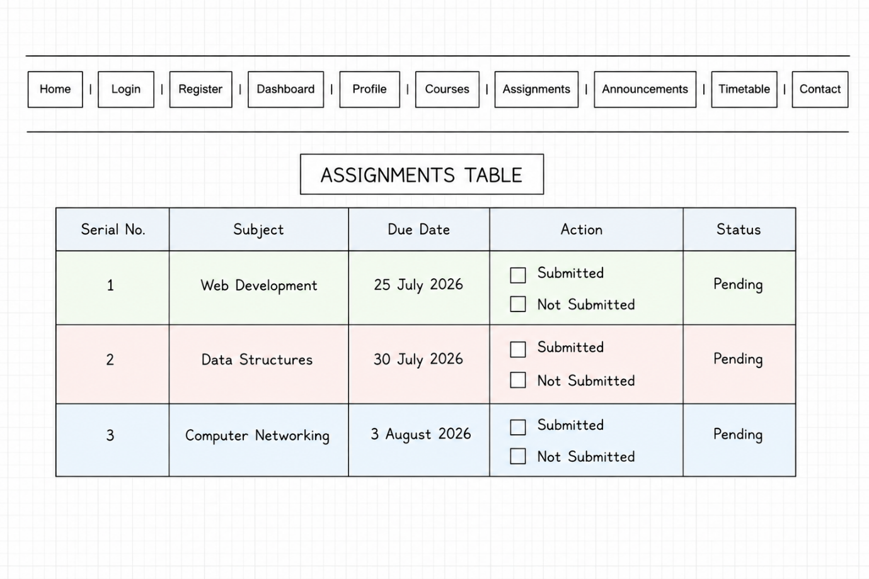
8.annoucements.html
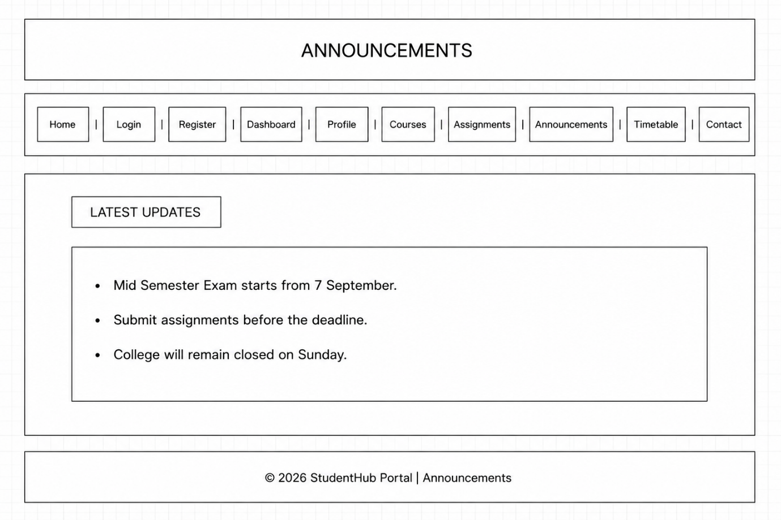
9.table.html
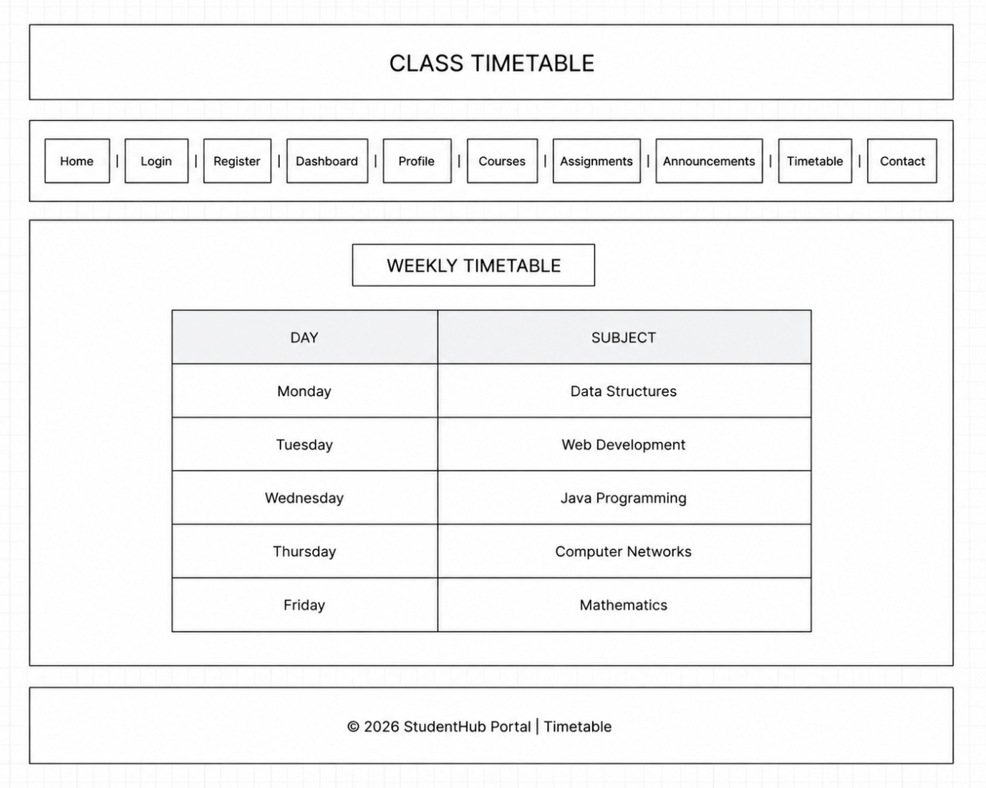

10.contact.html
